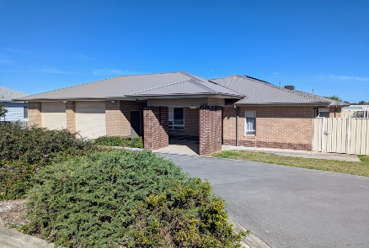
Ameeyk House Overnight

Name of participant:

Refer to monthly calendar attached for available dates to choose from.

Overnight Bookings Requested (Dates) |  | Comments
Month of

Month of

Month of

Month of

Please return completed form to Ameeyk House Supervisor at Kyeema as soon as possible

